04/08/2025
Batch 1: Experiment 01
Name : Sampada Kelkar

1.Print hello world

#include<stdio.h>
void main(){
printf("Hello World");
}

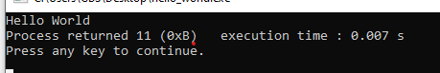

2.Print user information : name,class ,roll no

#include<stdio.h>
void main(){
char name[20],class[20],roll_no[10];
printf("Enter your name : ");
scanf("%s",name);
printf("Enter your class : ");
scanf("%s",class);
printf("Enter your roll no : ");
scanf("%s",roll_no);

printf("Name : %s\n",name);
printf("Class : %s\n",class);
printf("Roll no : %s",roll_no);
}

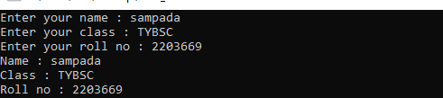

3.Add two Numbers entered by user
#include<stdio.h>
void main(){
int num_1,num_2,sum=0;
printf("Enter first number : ");
scanf("%d",&num_1);
printf("Enter second number : ");
scanf("%d",&num_2);
sum=num_1+num_2;
printf("Addition is %d",sum);
}

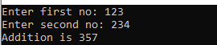

4.Basic calculator (addition,subtraction,multiplication,division)
#include<stdio.h>
void main(){
int num_1,num_2,sum=0,mul,sub,div;
printf("Enter first no: ");
scanf("%d",&num_1);
printf("Enter second no: ");

scanf("%d",&num_2);
sum=num_1+num_2;
sub=num_1-num_2;
mul=num_1*num_2;
div=num_1/num_2;

printf("Addition is %d\n",sum);
printf("Subtraction is %d\n",sub);
printf("Multiplication is %d\n",mul);
printf("Division is %d",div);
}

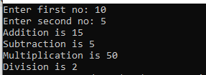
5.Evaluate expression x = a / b - c

#include<stdio.h>
void main(){
float x,a,b,c;
printf("Enter a ");
scanf("%f",&a);
printf("Enter b ");
scanf("%f",&b);
printf("Enter c ");
scanf("%f",&c);
if(b==0){
printf("division by zero");
}
x=a/b-c;
printf("Result of x=a/b-c is %f",x);
}

